CHAPTER 2-4

from FSM to operational systems

- An FSM is an abstraction. We can turn an FSM into an operational system in any of a number of ways:
  - An FSM can be translated into a circuit design and implemented directly in hardware.
  - An FSM can be simulated by software.

Simulating DFSMs directly

Ex2-4-1 L={w∈{a, b}*:w contains no more than one b}. L is accepted by the following DFSM M:
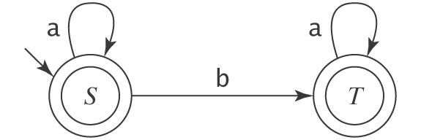
We can simulate M by the following program:

Interpreting DFSMs

- Here is a simple DFSM Interpreter:
dfsmSimulate(M: (K, Σ, δ, s, A):, w: string) =
st = s
do
{
c = getNextSymbol(w)
if c ≠ EOF then
if (δ(st, c) exists) then st = δ(st, c) else reject
} while c != EOF
if st ∈ A then accept else reject

Homework problems

- Write a Java program to read in a DSFM, then decides if an input string is accepted by the DSFM or not. You can assume the input DSFM is legal, and states are named with single letters.
Note:
- The program has 2 parts:
    - Read in the start state, the final states, and the transitions of the input DSFM. (no need to read K or Σ since the transitions would imply those)
    - Use a Vector<String> to store the set of final states.
    - Use a Vector<String> to store the set of transitions.
- Determine if an input string is accepted or rejected based on algorithm dfsmSimulate.
    - String methods such as startsWith and substring are useful.
- The following run is for the DSFM described in Ex2-4-1:
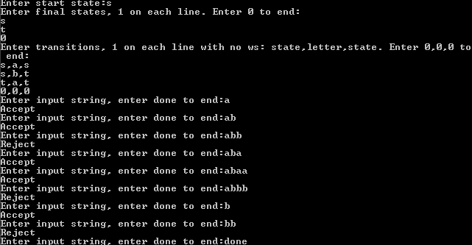

  - Email the file DSFM.java.
  - Hand in a hard copy of DSFM.java.

